Chat Application

Project Setup:
1. Navigate to - https://github.com/Ayeshaq09/Unified-mentor-projects You will see all 8 projects.
2. To get the projects onto your system: click on "Code" button and copy the link - https://github.com/Ayeshaq09/Unified-mentor-projects.git
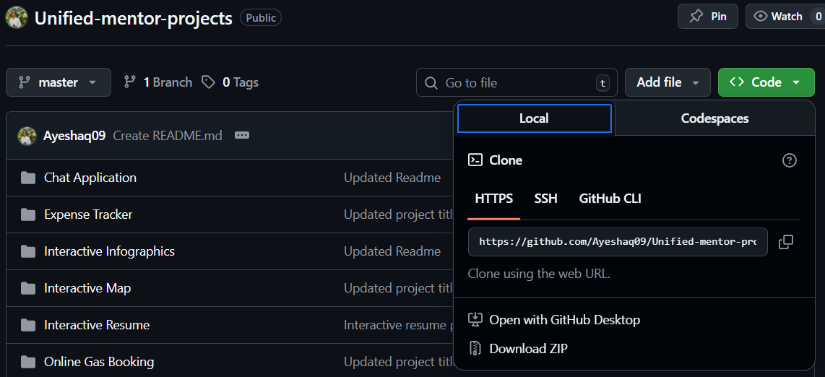
3. Open git bash and run the following command:
git clone https://github.com/Ayeshaq09/Unified-mentor-projects.git
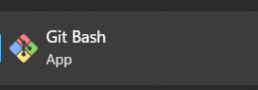
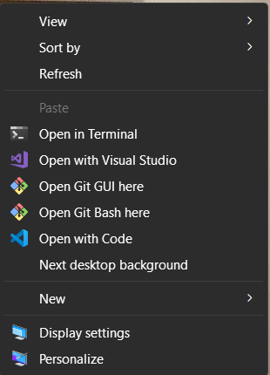
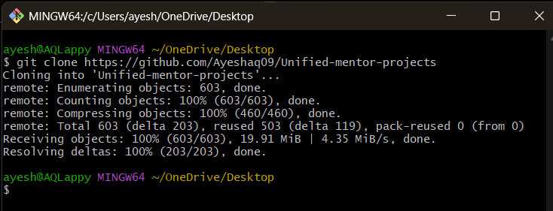
4. Once cloning is done, you get all the 8 projects onto your system.

Chat Application project setup:
1.Open the folder in vscode and in terminal run - npm install
This command will install all the dependencies required for the project to run.
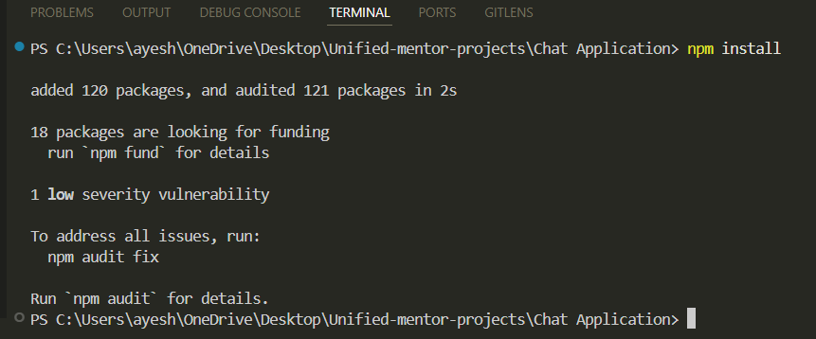

2. Then to run the project, use the command – npm start
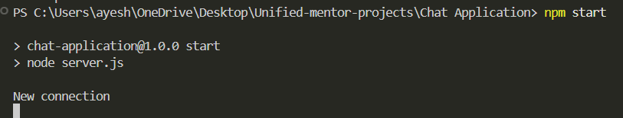

3. Type http://localhost:3000/ in chrome to view the project.
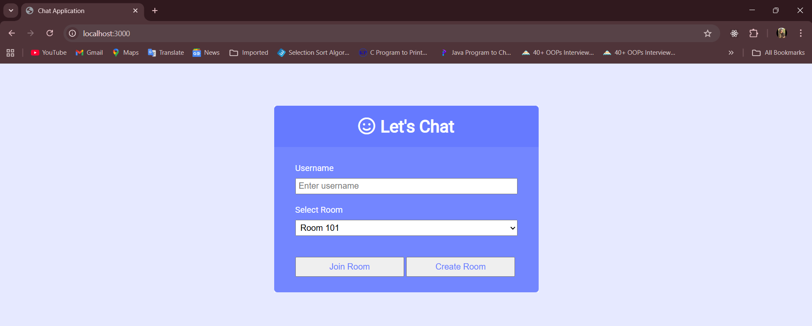

Functionality of the application:
- The first page displays form to add the username, select the room and then join the room.
In example below, I have added two people – Ayesha and Mohan to Room 103.
To add “Mohan” or more users, Type http://localhost:3000/ in another chrome instance.

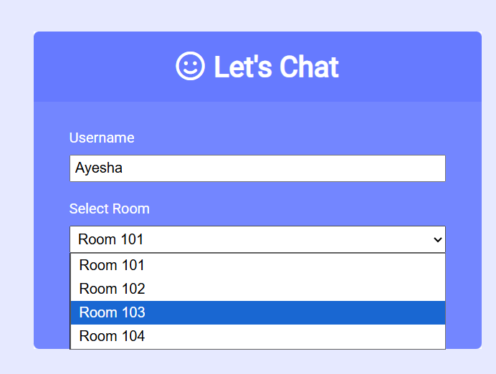
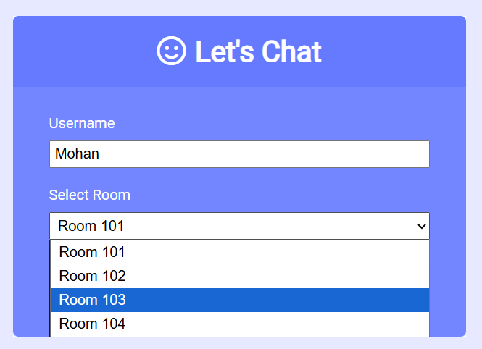

- You can also create your own room using Create room button, add room name and then select the newly added room to chat.
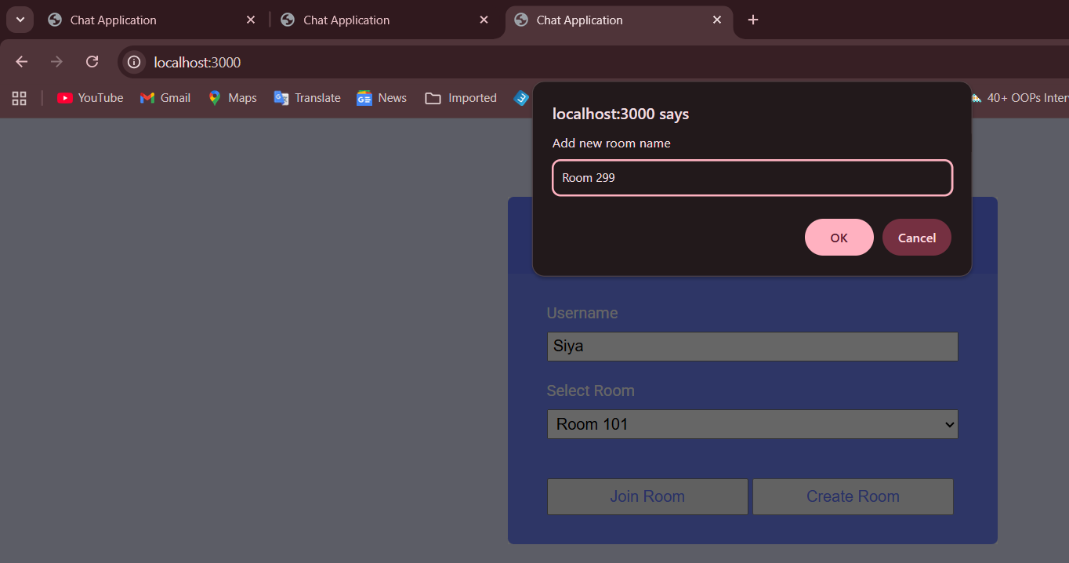
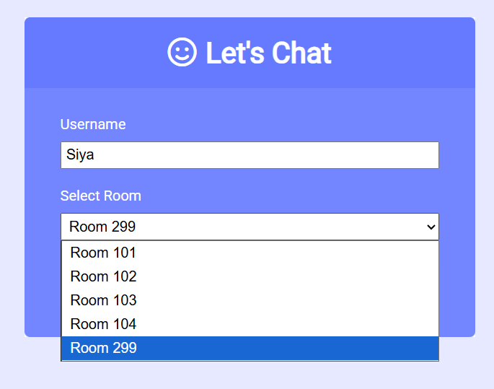

- You cannot add the same username. Username has to be unique.
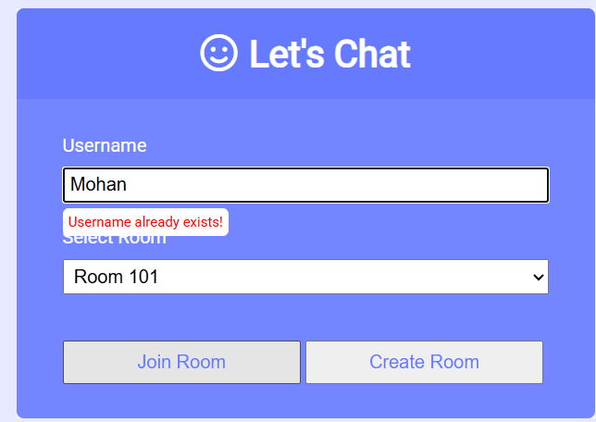

- After joining the particular room, it opens another page where on the left you can see the users in the particular room and the room name.
Eg: In Room 103 there are two users – Ayesha and Mohan
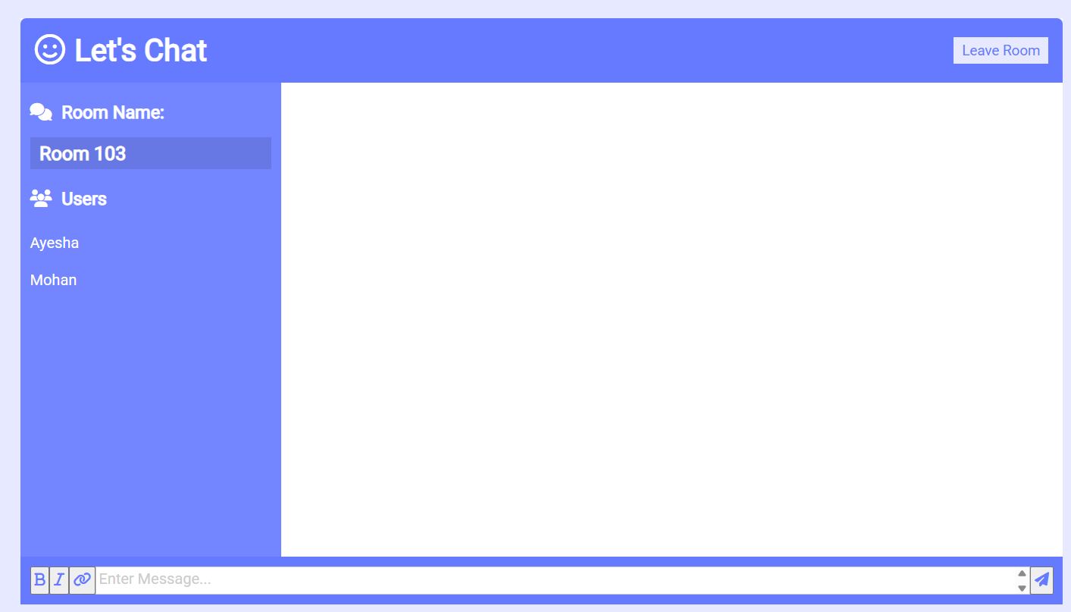

- On right is the chat panel where you can send messages to other users and also few chat formatting options are available.
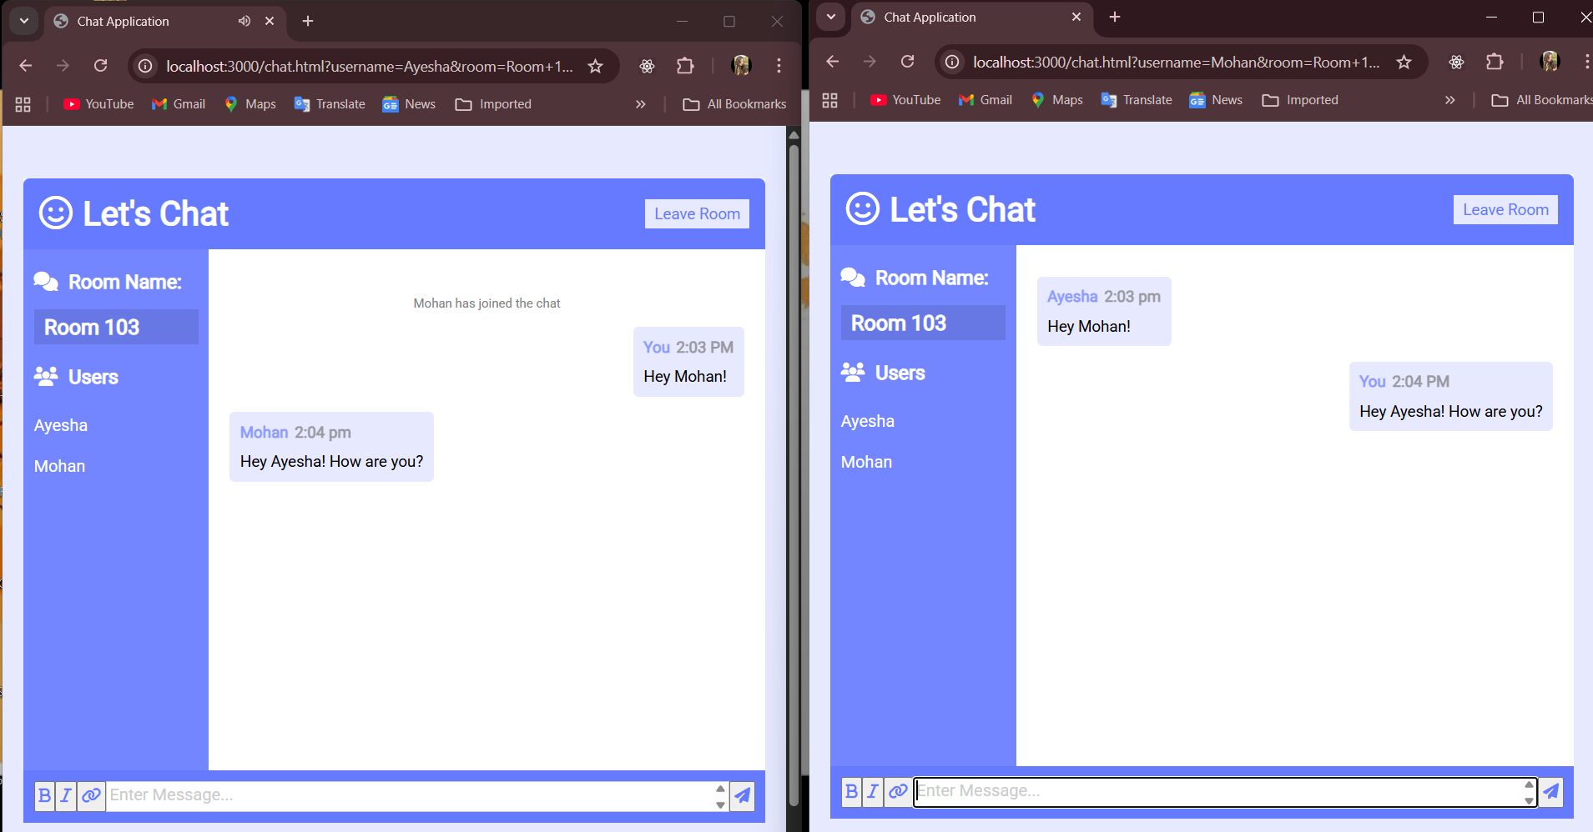

Text formatting options:

- The message sent by you will appear right and other user's messages will appear on left with the time and username details.
But the same message appears on left to Mohan.
Message sent by Ayesha appears on right.

- Also, you will get the notifications in the chat panel when user leaves or joins the particular room.
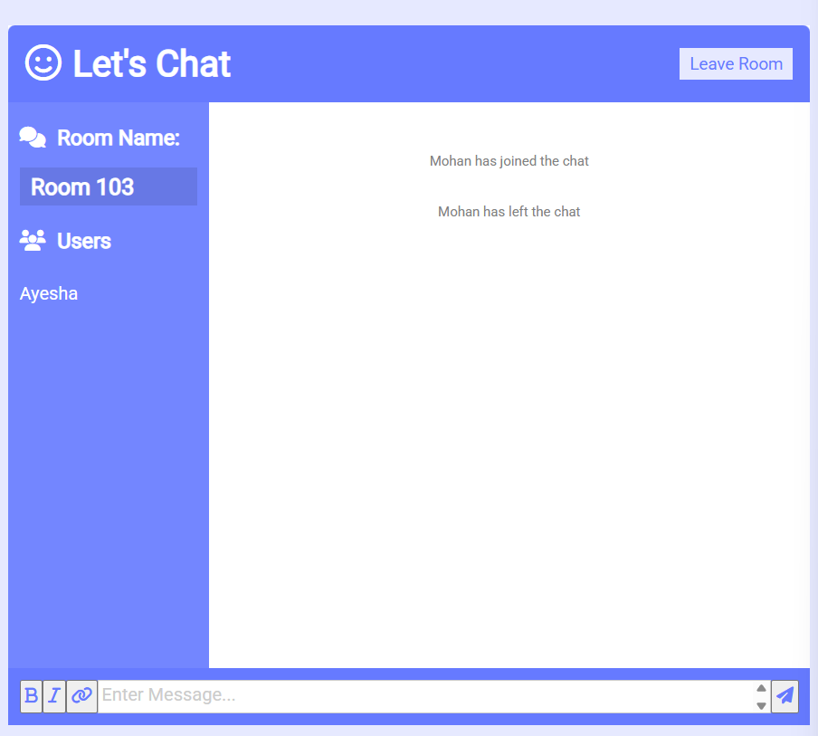

- To check the functionality, enter this URL - http://localhost:3000 in multiple tabs of the browser.

- Enter different username in each tab to act as different users and join the same room.

- Things to check - try entering same username, select same rooms to check the chat functionality, check message alignment when sent by you and others, create new rooms and use that room name and join using other usernames to check for active users in the room, join and leave the room to check for notifications in chat panel and also check the active users when users leave and join the rooms.

- Also check for the responsiveness of the application.

